

ASPIRE SEMH OUTREACH RERERRAL FORM
Please ensure all sections are completed within the form or we
cannot accept the referral.
Pupil Details
Pupil Name | Click here to enter text.
D.O.B. | Click or tap to enter a date.
Gender | Click here to enter text.
Year Group | Click here to enter text.
UPN | Click here to enter text.
Academic attainment – Age related or below | Click here to enter text.

Person completing this form
Date Referred to Outreach | Click here to enter text.
Referring School | Click here to enter text.
Trust Name or LA Maintained | Click here to enter text.
Referrer - Full Name and job role | Click here to enter text.
Contact Number | Click here to enter text.
Contact E-mail | Click here to enter text.

Current attendance Please tick

Overall attendance for 23/24 |  | Current Attendance for 24/25 |  | Full Time timetable
Suspension 23/24 (days) |  | Current Suspension 24/25 (days) |  | Part Time timetable



Part 1: Parental/ Carer Consent (No referral will be accepted without consent)
PARENTAL CONSENT FORM
Any information included within this referral will be used by the Primary/Secondary Rotherham Inclusion Pathway teams to help us tailor services for your child. Information will be treated as confidential, and stored in a secure way. It will only be shared with other council services and partner organisations to ensure our records are kept accurate and to help us identify other services your child may be entitled to. The staff from the team working with your child will report on assessment and or intervention findings and discuss with you, and your child/ young person’s school/nursery. In order to work effectively, the team liaises with other services working with a child/ family and shares any written advice with professionals involved in the Team working Around the Child or young person.
I confirm I understand why you want my information and I have had the opportunity to consider this. | Please highlight as necessary:  Yes No
I agree that the information presented within this referral may be shared with other professionals who are already involved with my child, or other agencies that may become involved in the course of any support offered to my child. | Please highlight as necessary:  Yes No
I give consent for you to record and hold my information for the purposes explained to me. | Please highlight as necessary:  Yes No
I consent to my child receiving the services provided by the Primary/Secondary Rotherham Inclusion Pathway Team | Please highlight as necessary:  Yes No
I would like updates throughout their support from the Outreach about my child. I understand this will not be weekly and can be through email/text/phone call. | Please highlight as necessary:  Yes No
Information Sharing and Consent
I understand that the information I have provided to Rotherham Metropolitan Borough Council regarding my child and family will be recorded and used for the purpose of providing services, support, advice and guidance to my child and family. I agree to my family’s personal information being processed and shared by Rotherham Metropolitan Borough Council with appropriate partners and organisations to enable them to provide us with services, support, information, advice and guidance in order to achieve a positive outcome for me and my family. Rotherham Metropolitan Borough Council is the Data Controller for the processing of my personal information and that will process all personal information in accordance with the Data Protection Act and GDPR.
Signature: Date:

Printed name:

Part 2 Details for the child and the parent/carer:

Student Details
Address | Click here to enter text.
Ethnicity and Language | Click here to enter text.
SEND Code (Monitoring, K) and Primary Need | Click here to enter text.
EHCP (Yes /No / In process) Primary Need | Click here to enter text.
Medical Information (ongoing assessments or known e.g. Epilepsy/allergies) | Click here to enter text.

Vulnerable Groups
Early Help | Click here to enter text. | Asylum seeker / Refugee | Click here to enter text.
Child in Need / Child Protection Register | Click here to enter text. | Emotional based school avoidance | Click here to enter text.
Looked after Child If so by which authority | Click here to enter text. | Traveller | Click here to enter text.
Pupil Premium | Click here to enter text. | EAL | Click here to enter text.
Young Offender | Click here to enter text. | CSE / CCE Risk | Click here to enter text.
Young carer | Click here to enter text. | SAMP in place (Date) | Click here to enter text.

Parent/ Carer with parental responsibility (SEMH Outreach Specialists will communicate with families throughout support)
Name of Parent/ Carer (Relationship to the child | Click here to enter text.
Address | Click here to enter text.
Telephone number / Email | Click here to enter text.
Part 3 Contact details for key school staff and professionals involved: (Please attach reports as evidence of graduated response to education, health, social care, voluntary etc.)

Role/Designation | Name | Contact Details | Last involvement / advice & report date
SENCO
Headteacher
Safeguarding contact if not Headteacher or SENCO
Social Worker/ Early Help Worker
Youth Offending Team
External SEND support
(SiT, OT, Fusion etc)
CAMHS Assessment
Educational Psychologist
EHC Assessment Coordinator
(HUB Allocation)
Other voluntary organisations or referral

Part 4 One Page Profile - Please attach Student Support Plan or complete the following framework. Please add any existing detail for SEMH/Learning Assessment if applicable. Please also send copy of EHCP if this is in place.

Reason for referral – what advice is required?
Strengths/Capabilities | Strategies that are in place currently
Barriers to learning | Triggers
Schools desired outcome for pupil (e.g- support with developing need impacting on learning. Using professional opinion based on knowledge of the child)

Part 5 Risk Assessment – Tick relevant rating and if this is known or opinion

Risk Assessment - Presenting behaviour | Low | Medium | High | Known | Opinion
Self-harm
Peer on Peer abuse
Violent/aggressive behaviour
Impulsive/dangerous behaviour
Substance/alcohol misuse
Derogatory opinions race/gender/religion/disability
Absconding
Damage to property
Offending
Sexualised behaviour / language
Carrying/using a weapon
Other (please specify)
Actions required to control/ minimise risk

Part 6 - SEMH Assessment: These are separate attachments but need to be returned at the same time the referral form is submitted. This will support the measurement of progress from the start of support.
Developmental Assessment
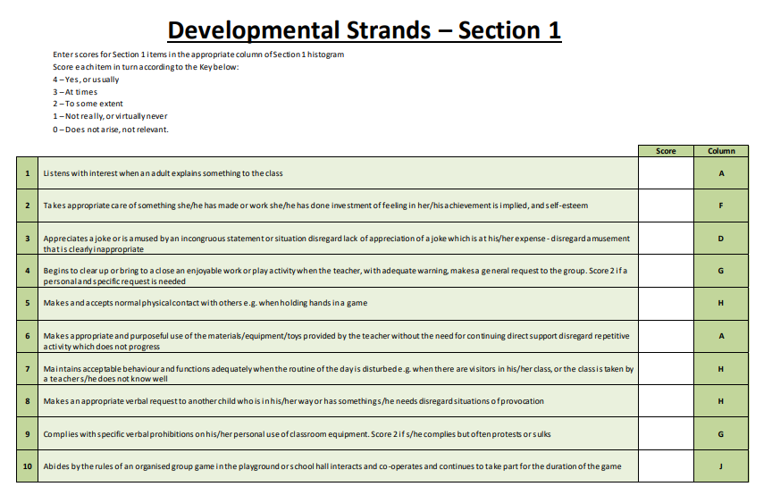

The developmental strand measures a pupil’s cognitive, social and emotional development that influences how well a child is able to learn and function in the classroom.

Diagnostic Assessment
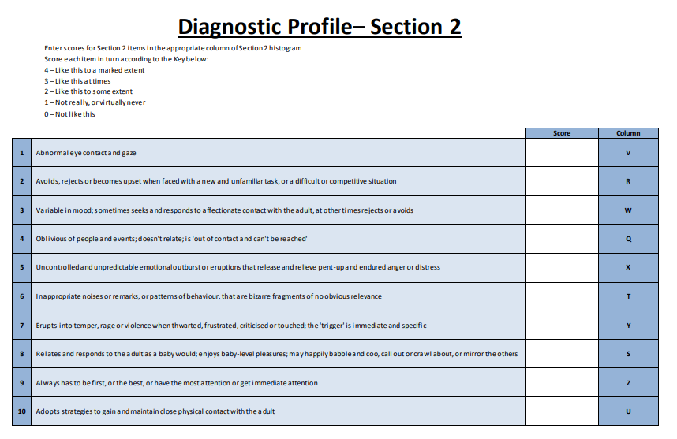
The diagnostic strand helps to spot any challenges or barriers that might prevent a child achieving at school.

